ELECTRO ENCEPHALOGRAPHY

Introduction
• The EEG (electroencephalograph) is a simple yet highly
useful instrumentation device.
• Neural activity electrical activity
• An EEG monitors the electric potential just outside the
surface of the skull.

History
• Galvani discovers electricity in animals (1791). This
was confirmed by Von Humboldt (1797) and Aldini
(1794).
• Ernst Fleischl von Marxow writes that the visual cortex
exhibits electrical activity (1833).
• Caton describes the observed "continuous spontaneous
electrical activity" of the brain surface (1875).
• Beck describes an investigation of electrical activity of
rabbit and dog brains, including oscillations altered by
light stimulus (1890).
Sherrington describes inhibition at neuronal
synapses (1906).
• Pravdich-Neminsky records an EEG on
photographs (1912).
• Forbes publishes the pioneering use of the vacuum
tube to replace string galvanometers for amplifying
EEG (1920).
• Berger describes scalp recording of human EEG
(1929). He then applies Fourier analysis to EEG,
with Dietsch (1932).

Though structural neuroimaging options are now available (MRI, CT),
the EEG is still the most widely used neural-function test.
Commonly applied to:
● seizure patients
●migraines, TIAs, other non-epileptic conditions
● carotid endarterectomy (clamping of carotid), cardiac surgery, and
other neurosurgical procedures
In recent years, it has been a profitable focus of medical
instrumentation companies.
Transducer
By coupling a buffer to the electrode, interference can be
heavily reduced.
● costs more
● avoids skin preparation
● protects the brain
from electrical shocks

Control
Firmware:
● often around one hundred lines of code

● writes appropriate packet headers
● performs A/D conversion
Maintaining precision and accuracy of the analog
signal is the major challenge.

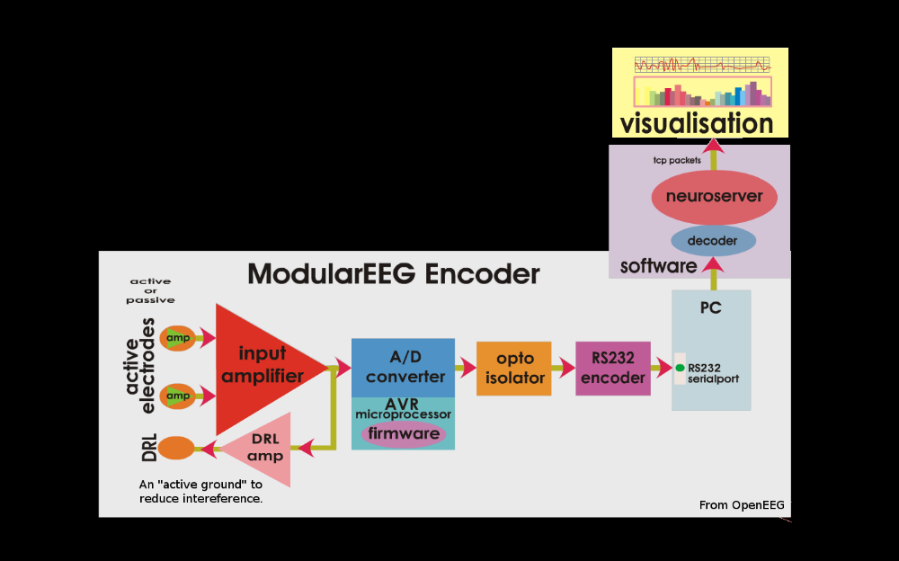

Other Uses
• Military Telepathy:
DARPA has pushed $4M USD towards pre-vocal signal
recognition in the battlefield
• Video Games:
Emotiv. Technologies released short video games that use
an EEG device to create "brain controlled" video games.

